# 

# ALPHA INSTALLATION MANUAL SUPPLIMENT SEC. 12

**915, VOLTAGE, THERMOCOUPLE RESISTANCE**

**and STRAIN GAUGE MODULE**

# 

**CONTENTS:**

ALPHA INSTALLATION MANUAL SUPPLIMENT SEC. 12 1

2

12. ALPHA 915 MULTIPLE MODE ANALOG MODULE 3

12.1 DESCRIPTION 3

12.1 SPECIFICATION 4

12.2 PROGRAMMING COMMANDS 6

12.3 CONNECTION DETAILS 9

12.4 INPUT CONNECTION DIAGRAMS 10

12.5 STRAIN MEASUREMENT CONSIDERATIONS 12

# 

# Issue 1 12/7/2021

# 12. ALPHA 915 MULTIPLE MODE ANALOG MODULE

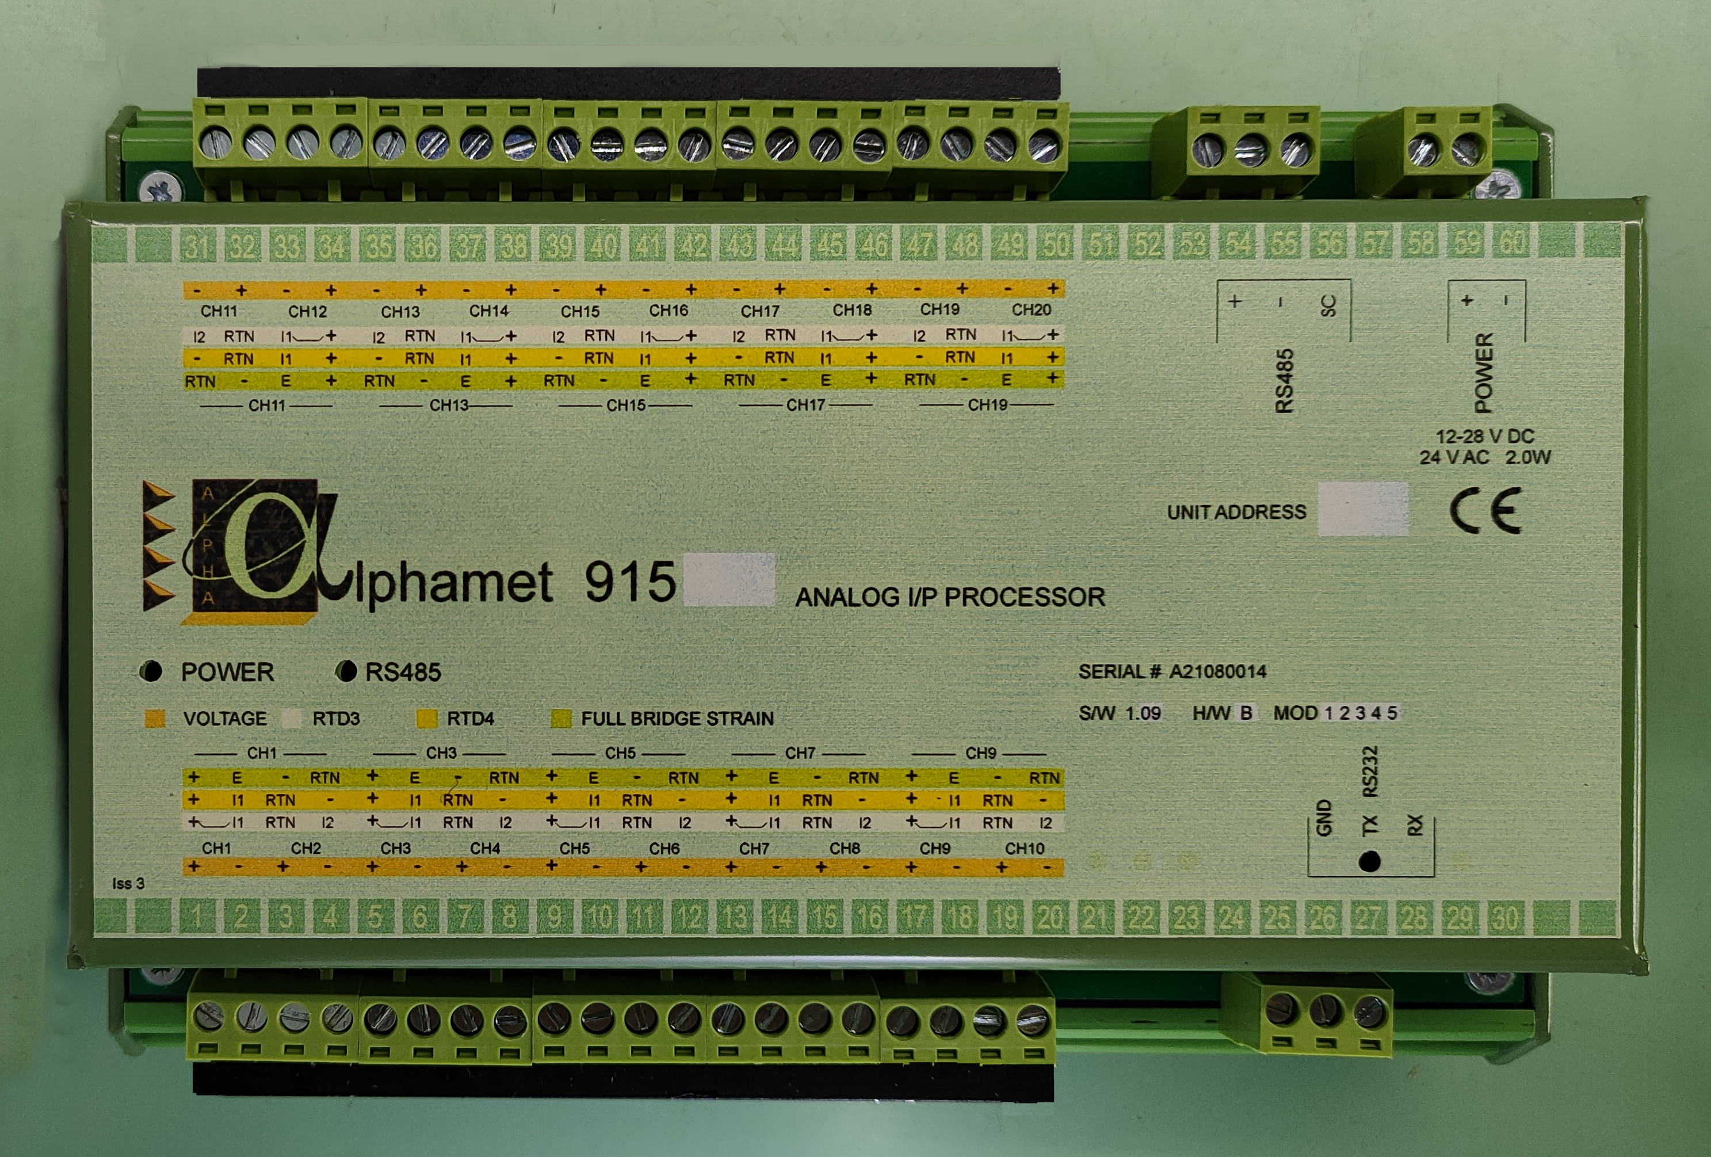

## 12.1 DESCRIPTION

The 915 provides 20 two-pole channels, which can be used for thermocouple, voltage or current measurement. Pairs of these channels can be combined to make four pole measurements for four and three pole resistive, PRT and thermistor sensors. Current energised full bridge strain gauge measurements with four poles are also supported for strain gauge bridges, pressure transducers and load cells. Any odd numbered channel can be paired with the following even channel number to form a four pole channel.

Measurements can be made with up to 19 bit resolution and 1uV integrity.

Thermocouples are cold junction compensated and can be monitored for failure or deterioration during normal operation automatically. Types K,J,T,R,S,E,B and N are supported by the standard firmware.

Current measurements can be made using an external current shunt or with an internal shunt if specified at time of supply.

Resistance, PRT and thermistor measurements can be made with 3 or 4 Terminal sensors with sensitivities of 1mOhm. The PT100 PRT standard and the Fenwall UUB31J1 thermistor are supported in the standard firmware.

Strain bridges with 1000 to 100 Ohm resistance can be measured. The firmware assumes a 350 Ohm bridge for scaling, The measurement resolution of a 350ohm strain gauge bridge with two active gauges can be as high as 0.1uE. Initial bridge unbalance can be compensated for. The bridge energisation for strain gauge measurements is pulsed therefore reducing errors due to heating effects of the sensors. For 350 Ohm bridge it is also applied symmetrically about the bridge so that the measurement leads across the bridge are kept close to 0V and do not have to charge up to make a measurement. This improves the performance and eliminates cable dielectric secondary storage effects on long cable runs which can otherwise cause measurement errors.

High quality convenient cage clamp two part screw terminals are used for all primary channel connections.

The 915 can be programmed to integrate signals to be measured over one or more complete mains cycles (50 - 60 Hz) allowing measurements to reject large levels of mains borne interference super imposed on micro-volt signals. During a measurement an auto-ranging facility ensures an input channel is measured on the best range to maintain maximum measurement resolution. A choice of measurement conversion resolution and speed is provided. These features together with a digital filter function and precision hardware design achieve excellent noise performance for all measurement functions.

Measurements, measurement linearisation, measurement processing and communications are concurrent tasks for optimum performance. Calibration is performed by applying reference inputs and issuing commands to the module. No internal access is required.

As with most other modules in the Alpha series a local serial interface can be used to program and monitor operation locally independent of the communications on the RS485 network. This can be very convenient during installation or used later to diagnose application problems at the measurement site

## 12.1 SPECIFICATION

Number of channels / module 20

Number of 4 pole channels up to 10

Number of 3 pole channels up to 10

Connector type input channels Two part screw terminal.

High quality cage clamp.

Measurement modes T/C

uV DC

mV DC

4-20mA ext shunt

4 Terminal Resistance

3 Terminal Resistance

full bridge strain

**A-D CONVERTER:**

Five measurement resolutions are supported: 19 bits at 10 measurements

per second

18 bits at 20 measurements/s

17 bits at 40 measurements/s

15 bits at 100 measurements/s

13 bits at 200 measurements/s

In addition a channel filter function can be applied to any channel.

**VOLTAGE MEASUREMENT MODE:**

Input voltage ranges +10V >-10V

+1.5V >-1.5V

+180mV >-180mV

+23mV >-23mV

Automatic range selection is supported.

DC measurement accuracy +/- 0.015% of reading + 0.01% of range + 6uV

Temperature coefficients DC voltage 25ppm rdg + 0.1uV/oC

Measurement sensitivity <0.25uV on +23mV>-23mV

range at 18 bits

(Note: displayed sensitivity depends on reporting format)

Additional error at 200/sec mode 0.05% of range

**THERMOCOUPLE MEASUREMENT ACCURACY:**

Internal Cold junction compensation errors included:

(External compensation is also available)

Type Range Accuracy

K -100 to 500 0.6oC

500 to1200 0.7

1200 to 1600 3.0

J -50 to 360 0.6

360 to 800 0.7

T -150 to 400 0.6

R 0 to 1600 2.0

S 0 to 1700 2.2

E -50 to 290 0.7

290 to 1000 1.0

B 200 to 1600 4.5

N -200 to 1600 1.5

-100 to 580 1.1

580 to 1300 1.3

Displayed sensitivity <0.1oC

Thermocouple Health Monitoring Automatic

**RESISTANCE MEASUREMENT:**

Measurement Ranges 2000 ohm

256 ohm

32 ohm

Sensing Current <0.75 mA (switched)

Accuracy 256R 0.02% rdg + 0.015% rng +2 mohm

4 Terminal mode

**RTD MEASUREMENT:**

PT100 -50 to 400 oC +/-0.2oC

-150 to 600 oC +/-0.4oC

4 Terminal mode

**FULL STRAIN MEASUREMENT:**

350 ohm Bridges

Accuracy full bridge (repeatability) 5uE

Sensitivity at 18 bits 0.1uE

( 2 active gauge GF=2)

Energisation 5mA pulsed

120 OHM Bridges

Accuracy full bridge (repeatability) 10uE

Sensitivity at 18bits 0.2uE

( 2 active gauge GF=2)

Energisation 5mA pulsed

**INTERFERENCE REJECTION:**

AC Common mode rejection ratio channel group <0.1uV/V

AC Single channel common mode rejection ratio <1uV/V

DC channel common mode rejection ratio <5uV.V

AC series mode rejection ratio 50 or 60 Hz

+/- 0.05% <1mV/V

Applies to 17,18,19 bit measurements

Maximum voltages operating:

Maximum voltage between any (+) and all (-) inputs 12V

Maximum voltage between any two (-) input terminals 11V

maximum Voltage between any two terminals 22v

**OVERLOAD PROTECTION:**

Channel overload protection Passive

50V continuous

150V for short periods

**ISOLATION:**

Isolation test voltage between channel group

and power supply or RS485 Tested at 1000V.

Input current of instrumentation amplifier 5nA

Input impedance of operating >10m 0-12V

**POWER REQUIREMENT:**

Connector 2 pole screw terminal

Voltage 24V AC l

12 to 28V DC

Current 200mA at 12V

120mA at 24V

**GENERAL:**

RS485 INTERFACE See manual

Baud rates to 153KB

Local serial interface Rx Tx 5V levels

Compatible with most

RS232 peripherals

Baud rates to 38K4

Status Leds Power,RS485,RS232

Operating Temperature Range -20 to 70oC

Relative Humidity <90% 0 to 40oC

Vibration 3g 0 to 400Hz in 3 planes

Size 180*117*60mm

Weight 600g

Mounting DIN rail

Programming and calibration storage Secure flash memory

(Accuracies are stated 18 bit ADC resolution,at 21’C for 1Yr )

Issue 1.2 DS915A04 Refers to 1.09 firmware. All Specifications subject to change without notice. Correct at time publication.

## 12.2 PROGRAMMING COMMANDS

For a full list of commands refer to appendix B of the Alpha installation manual. The commands for programming measurement modes supported by this module are described here. Any special considerations in the use of other commands are also described in this section. Other commands supported by this module are also listed below.

#### SET CHANNEL MODE @AA.cc-dd:CMp1,p2,p3,p4

Where:

p1 Measurement type

0 skip

1. voltage
2. Current
3. Thermocouple internal CJC
4. Thermocouple External CJC
5. CJC temperature (ambient)

10 RTD 4 terminal

11 RTD 3 terminal

14 Full bridge strain

Parameter p2 is sensor or unit type , its values depend on the value of parameter p1

When p2 values

p1=1 0 uV

1. mV

For p1=2 p2 Type

0 0-20mA(default)

1 0-100%

For p1=3 or 4 p2 Type

0 K(default)

1 B

2 E

3 J

4 N

5 R

6 S

7 T

For p1=10 or 11 0 Resistance in ohms

1 PT100 European standard

For p1=14 0 No options

Parameter p3 forces the range that measurement is taken on and not normally used. If p3 is set to zero, the range will be selected automatically.

0 Automatic range selection

1 20mV

2 180mV

3 1.5V

4 12V

Parameter p4 selects measurement resolution and integration time

0 17bit 20mS/16.67mS default (40 measurements/sec)

1 13 bit 1.0mS (200 measurements/sec)

1. 15 bit (100 measurements/sec)
2. 18 bit (20 measurements/sec)

4 19/20bit (10 measurements/sec)

#### CHANNEL INITIALISE @AA{.cc-dd}:CI

For thermocouples this command engages the background thermocouple health monitoring

This command causes initial conditions and strain gauge channels to be established. After this command is sent the measurements returned will be relative to the next measurement made for each channel . These reference measurements will be subtracted from all subsequent measurements. They can be saved to EAROM by using the SA command. Then in the event of a power interruption, the initial bridge balances will be retrieved.

#### CHANNEL RESET @AA{.cc-dd}:CR

This command will clear the strain gauge reference measurements established with the CI command and disable the thermocouple health monitoring.

**Other Commands supported by this module for version 1.09 software:**

**Command Function Parameters / range**

Communication @aa:CCp1

ADp1 Set module address 01 to 99

BAp1 Set baud rate local serial interface 3 or 4 3=9600 4 = 19K2

BBp1 Set baud rate RS485 3 to 6 3=9600 6=76K8

DFp1 Set report data format 0/1/2 Decimal / Integer /

IEEE fp

PBp1 RS485 protocol 0/1 TERMINAL / HOST

Channel Programming @aa.cc{-dd}:CCp1,p2

CMp1,p2 Set measurement type type, secondary parameter

CSv1,v2 Scale and offset scale, offset

CPp1 Enable channel scaling 0/1 off/scale

ALv1,v2,v3 Alarm limits high limit, low limit, threshold

AMp1 Alarm mode 0/1 off/level alarms

Return measurements @aa{.cc-dd}?

.1? returns channel 1 measurement

.1-10? Returns the measurement sof the first 10 channels.

? returns the measurements of all channels

Set auxiliary outputs @aa:AOp1

AOp1 Set auxiliary outputs 0-7 Three bit code OP3/2/1

Other module commands @aa:CCp1

SA Save configuration to eerom

LO Load configuration

CL Clear configuration

RU Run

HA Halt

Local monitor and diagnostic commands

MN Start channel monitor

MH Halt monitor

ID? Identify module type / serial number

IV? Interrogate software version

.cc:CC? Interrogate channel set-up (most commands with parameters)

CC? Interrogate module set up (most commands with parameters)

See appendix A and B of the Alpha Installation Manual for a full description of these commands and protocols supported.

In the case of 4 pole resistance and strain measurements using two channels, normally a result will be returned for each channel in any report format. The odd channel result will be the resistance or strain measurement. The following even channel result may be zero or contain diagnostic information. It should be ignored.

## 12.3 CONNECTION DETAILS

The following list is provided for plant wiring documentation. The terminal numbers are the green numbers on the product main label. The termination function is shown for each type of measurement referencing the connection diagrams below where necessary..

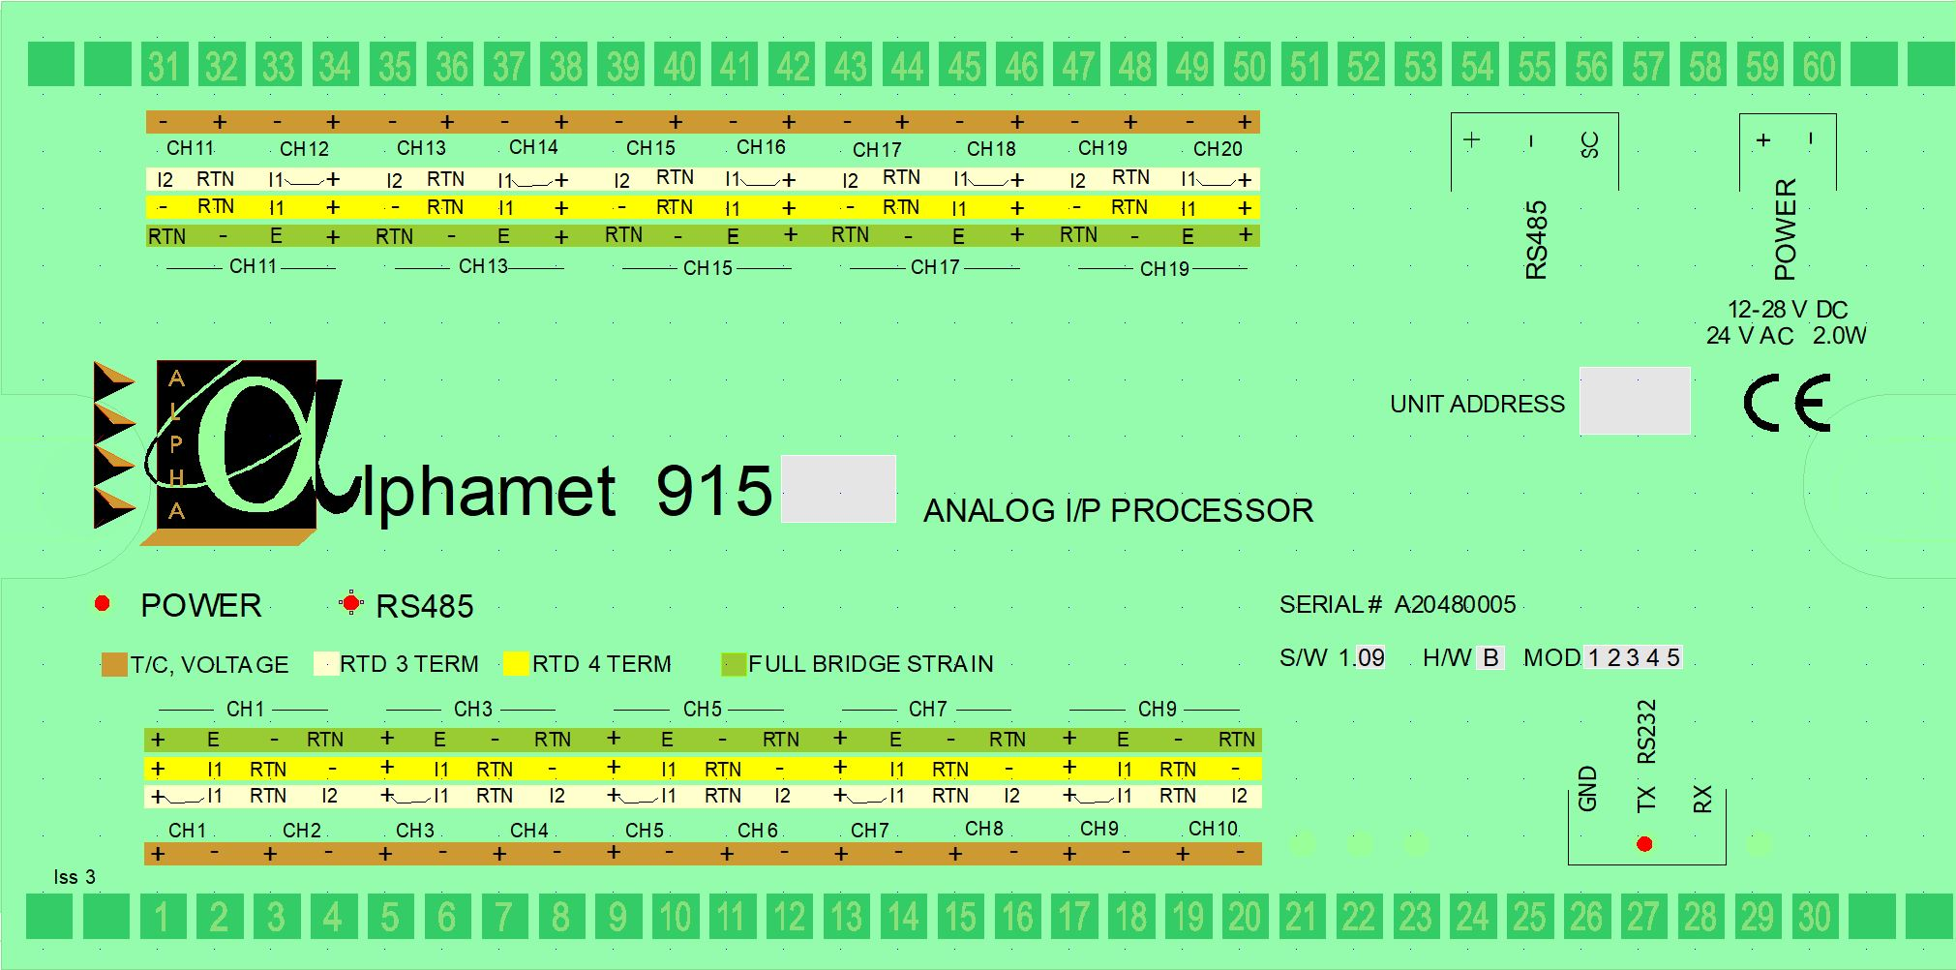

MEASUREMENT TYPE

TERMINAL VOLTAGE/CURRENT RESISTANCE/PRT/THERM STRAIN

THERMOCOUPLE 4 Wire 3 wire

Channel Channel

1 - CHAN 1 + INPUT, CHAN 1 +INPUT +INPUT +INPUT

2 - CHAN 1 - INPUT, CHAN 1 I1 I1 E

3 - CHAN 2 + INPUT, CHAN 1 RTN RTN -INPUT

4 - CHAN 2 - INPUT, CHAN 1 -INPUT I2 RTN

5 - CHAN 3 + INPUT, CHAN 3 +INPUT +INPUT +INPUT

6 - CHAN 3 - INPUT, CHAN 3 I1 I1 E

7 - CHAN 4 + INPUT, CHAN 3 RTN RTN -INPUT

8 - CHAN 4 - INPUT, CHAN 3 -INPUT I2 RTN

9 - CHAN 5 + INPUT, CHAN 5 +INPUT +INPUT +INPUT

10 - CHAN 5 - INPUT, CHAN 5 I1 I1 E

11 - CHAN 6 + INPUT, CHAN 5 RTN RTN -INPUT

12 - CHAN 6 - INPUT, CHAN 5 -INPUT I2 RTN

13 - CHAN 7 + INPUT, CHAN 7 +INPUT +INPUT +INPUT

14 - CHAN 7 - INPUT, CHAN 7 I1 I1 E

15 - CHAN 8 + INPUT, CHAN 7 RTN RTN -INPUT

16 - CHAN 8 - INPUT, CHAN 7 -INPUT I2 RTN

17 - CHAN 9 + INPUT, CHAN 9 +INPUT +INPUT +INPUT

18 - CHAN 9 - INPUT, CHAN 9 I1 I1 E

19 – CHAN 10 + INPUT, CHAN 9 RTN RTN -INPUT

20 – CHAN 10 - INPUT, CHAN 9 -INPUT I2 RTN

26 RS232 Ground

27 RS232 TX

28 RS232 RX

TERMINAL VOLTAGE/CURRENT RESISTANCE/PRT/THERM STRAIN

THERMOCOUPLE 4 Wire 3 wire

Channel Channel

31 - CHAN 11 - INPUT, CHAN 11 -INPUT I2 RTN

32 - CHAN 11 + INPUT, CHAN 11 RTN RTN -INPUT

33 - CHAN 12 - INPUT, CHAN 11 I1 I1 E

34 - CHAN 12 + INPUT, CHAN 11 +INPUT +INPUT +INPUT

35 - CHAN 13 - INPUT, CHAN 13 -INPUT I2 RTN

36 - CHAN 13 + INPUT, CHAN 13 RTN RTN -INPUT

37 - CHAN 14 - INPUT, CHAN 13 I1 I1 E

38 - CHAN 14 + INPUT, CHAN 13 +INPUT +INPUT +INPUT

39 - CHAN 15 - INPUT, CHAN 15 -INPUT I2 RTN

40 - CHAN 15 + INPUT, CHAN 15 RTN RTN -INPUT

41 - CHAN 16 - INPUT, CHAN 15 I1 I1 E

42 - CHAN 16 + INPUT, CHAN 15 +INPUT +INPUT +INPUT

43 - CHAN 17 - INPUT, CHAN 17 -INPUT I2 RTN

44 - CHAN 17 + INPUT, CHAN 17 RTN RTN -INPUT

45 - CHAN 18 - INPUT, CHAN 17 I1 I1 E

46 - CHAN 18 + INPUT, CHAN 17 +INPUT +INPUT +INPUT

47 - CHAN 19 - INPUT, CHAN 19 -INPUT I2 RTN

48 - CHAN 19 + INPUT, CHAN 19 RTN RTN -INPUT

49 – CHAN 20 - INPUT, CHAN 19 I1 I1 E

50 – CHAN 20 + INPUT, CHAN 19 +INPUT +INPUT +INPUT

TERMINAL 54 - RS485 '+'

TERMINAL 55 - RS485 '-'

TERMINAL 56 - RS485 'SC'

TERMINAL 59 – POWER +

TERMINAL 60 – POWER -

## 12.4 INPUT CONNECTION DIAGRAMS

#### Thermocouple , Voltage and Current input connection

Thermocouples and voltage output sensors are just directly connected to the + and – inputs of a channel.

The polarity of thermocouple connections are of course important for correct measurement. Cold junction temperature is sensed separately for channels 1-10 and 11-20. The cold junction temperatures can be displayed by using channel measurement mode 5 which can also serve as an ambient temperature measurement.

Recommended current loop arrangement:



Note that internal calibrated shunts can be fitted for particular channels committed to current measurement if specified. This can result in better accuracy. Care is then needed not to subsequently connect a voltage source to these channels as damage may result. For this reason and for flexibility, external shunts are often used as required.

**4 Wire RESISTANCE / PRT /THERMISTOR Connection**



**3 Wire PRT Connection**



Note I2 is a second current source, equal to I1, which cancels lead resistance.

**Full Bridge Strain Gauge Connection**



## 12.5 STRAIN MEASUREMENT CONSIDERATIONS

The strain is calculated from the resistive change of the active arm. The energising current is 5mA. One active arm, 350 Ohm bridge and a gauge factor of 2 is assumed by the firmware. The channel scale function can be used to allow for the actual gauge factor and also for additional active gauges in the bridge. The firmware assumes a 350R bridge resistance. As the bridge is current energised, for other bridge resistances ( eg 120R) an appropriate additional scaling factor is needed ( eg 2.916 for a 120R bridge) .

The strain is calculated from the bridge output voltage change due to the resistive change of the active arm(s). One active arm and a gauge factor of 2 is assumed by the firmware. The initial offset of the bridge, when no strain is present, can be cancelled using the @aa:CI command. This is similar to balancing the bridge. The last set of channel measurements made will be used as a reference measurements set for each of the channels set to strain function. These reference measurements will be subtracted from subsequent channel measurements. It is possible to apply the command to a single channel or a group of channels by specifying a channel range prefix to the command @aa.cc-ddCI.



The reference values can be saved to EEROM using the SA command.

The reference values can be reset to zero by using the @aa.cc-ddCR command. Old saved values

Can then be erased with the SA command.

If additional active arms are used in the construction of the bridge circuit, or a gauge has a specified gauge factor, then an additional scaling factor will be needed if engineering units are to be correctly returned to the host computer. The required scaling factor is as follows:

p1= (2/(G*N))*350/B

Where p1 is the required factor

N is the number of active gauges

G is the gauge factor or average gauge factor of the active gauges

B is the bridge resistance – eg 120R or 350R

The CS command can be used to implement this within the module so that strain measurements are returned to the host , and displayed locally if required, taking into account these factors. For the case of 2 active gauges, 350 ohm bridge . gauge factor 2, it would be:

@aa.ccCSp0.5,0

The CP command is then needed to enable channel processing on this channel:

@aa.ccCP1

This would be repeated for each channel needing a specific scaling factor. If all channels are similar the command can be sent once to the group of channels involved:

@aa.cc-ddCSp0.5,0

@aa.cc-ddCP1

For two active gauges, one in compression and one in extension for example on a bending beam, the sensitivity of the measurements mayl be doubled and the accuracy of the measurements will be improved in addition to achieving temperature coefficient compensation. The inherent non-linearity of a single gauge in a bridge will also be reduced.

The standard firmware presents a linear relationship between bridge output voltage and strain returned. For bridges with a single active gauge (and two gauge bridges where the second gauge is present for temperature compensation only), and where large strains are to be encountered, the inherent non-linearity of a bridge circuit may need to be taken into account depending on the accuracies required by the application. As the bridge is current energised , the treatment differs from that of a voltage energised bridge . The non linearity is inherently lower when a bridge is current energised.

For half and quarter bridges the Alpha 914 Module should be considered which is more specialised for strain menasurements.